COMP90042 Project2 Report

Group Number

Student Number1

Student Name1

Student Number2

Student Name2

Table of Contents

1. Introduction 3

2. System Description (functions) 3

2.1 Scenario 1 3

2.2 Scenario 2 3

... 3

3. User Guide for Testing 3

3.1 Deployment Guide 3

3.2 End User Guide 3

4. Design and Implementation 3

4.1 System Architecture 3

4.2 RESTful Framework 3

4.3 Twitter Harvester 3

4.4 Database 3

4.5 Data Analysis 3

4.6 Automated Deployment 3

5. Discussion of Tools and Platforms 3

5.1 UniMelb Research Cloud 3

5.2 Tools and Processes for Deployment 3

Appendix 3

# 1.Introduction

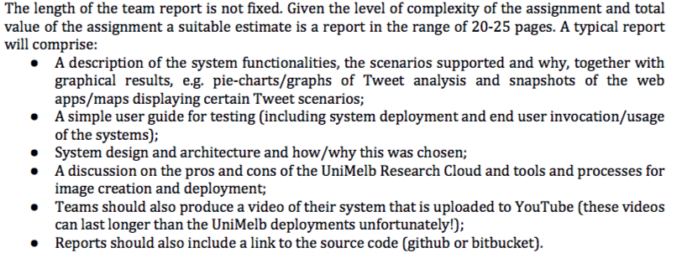

# 2.System Description (functions)

Sds.

## 2.1 Scenario 1

## 2.2 Scenario 2

## ...

# 3.User Guide for Testing

## 3.1 Deployment Guide

## 3.2 End User Guide

# 4.Design and Implementation

## 4.1 System Architecture

## 4.2 RESTful Framework

## 4.3 Twitter Harvester

## 4.4 Database

## 4.5 Data Analysis

## 4.6 Automated Deployment

# 5.Discussion of Tools and Platforms

## 5.1 UniMelb Research Cloud

## 5.2 Tools and Processes for Deployment

# Appendix

* Youtube Video
* GitHub link